**URL’s**

**WebApp URL -** [**http://ae401ecc4539246dcb3b310ff2638d74-1758321122.us-east-1.elb.amazonaws.com/**](http://ae401ecc4539246dcb3b310ff2638d74-1758321122.us-east-1.elb.amazonaws.com/)

**Circle CI URL -** [**https://app.circleci.com/pipelines/github/aamirsyper/aamirscap**](https://app.circleci.com/pipelines/github/aamirsyper/aamirscap)

**(Please consider aamirscap13 run)**

**Github URL -** [**https://github.com/aamirsyper/aamirscap**](https://github.com/aamirsyper/aamirscap)

**Docker Hub -** [**https://hub.docker.com/repositories/aamirsyper**](https://hub.docker.com/repositories/aamirsyper)

**Lint Failure**

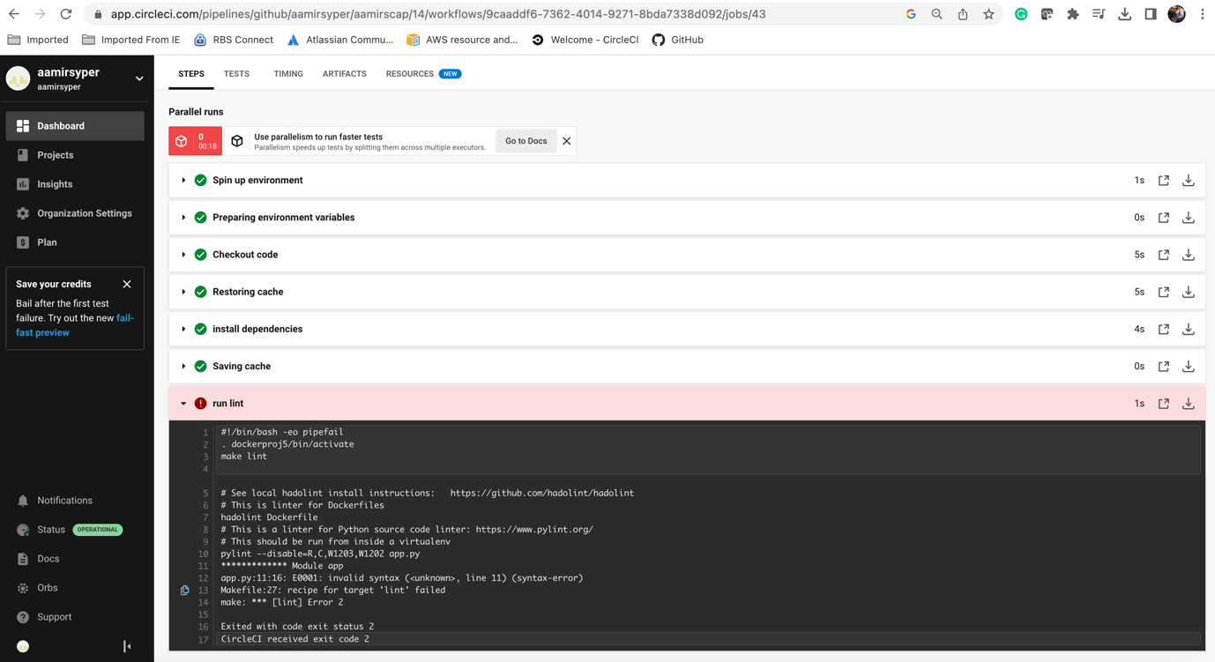

**Successful Lint**

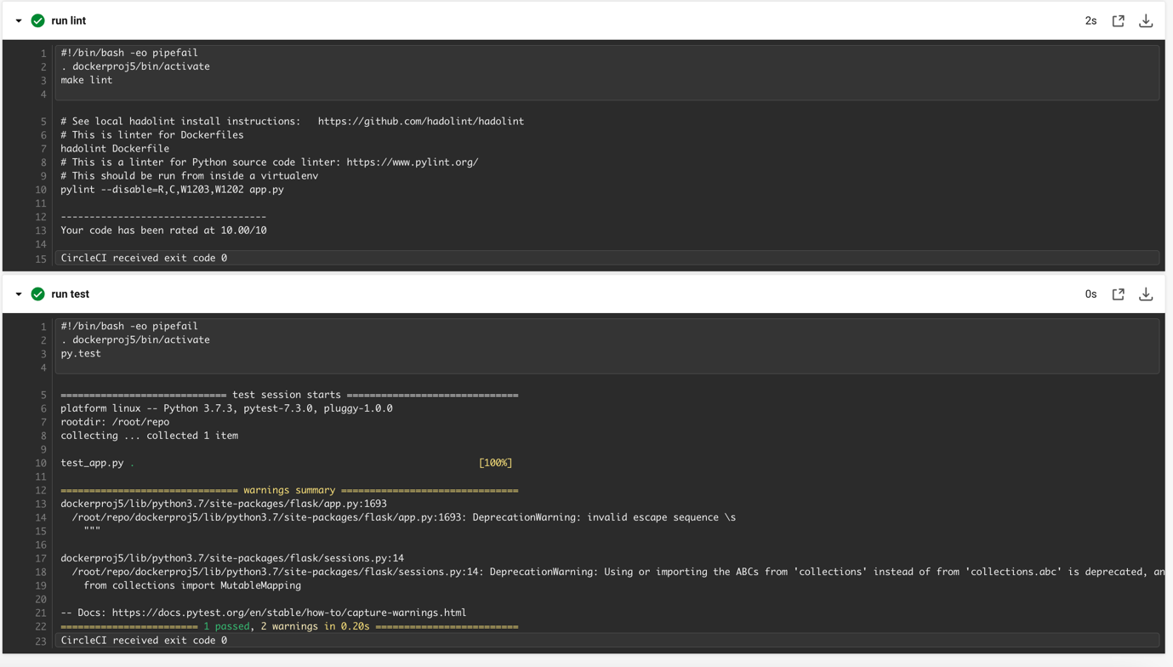

**Successful Pipeline creation**

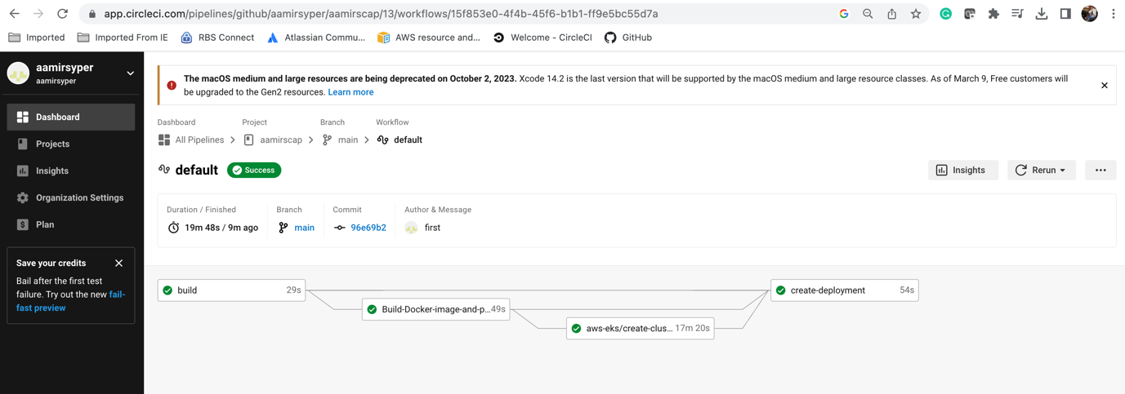

**Stack Creation**

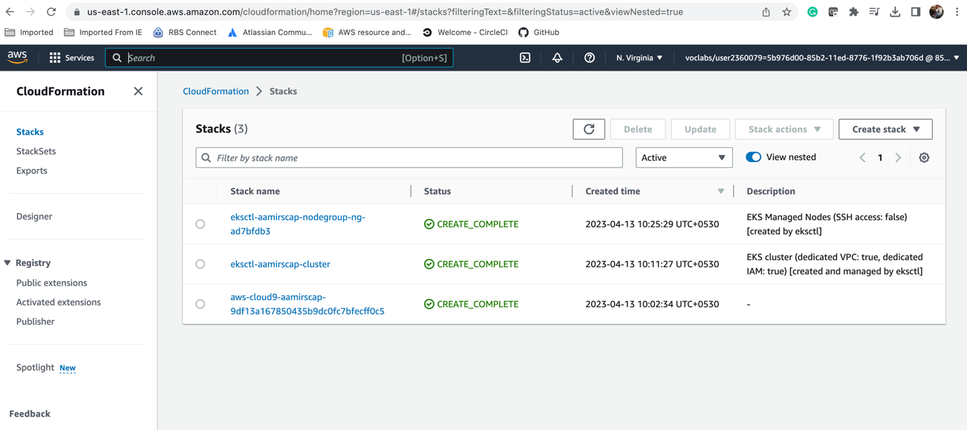

**Docker Build**

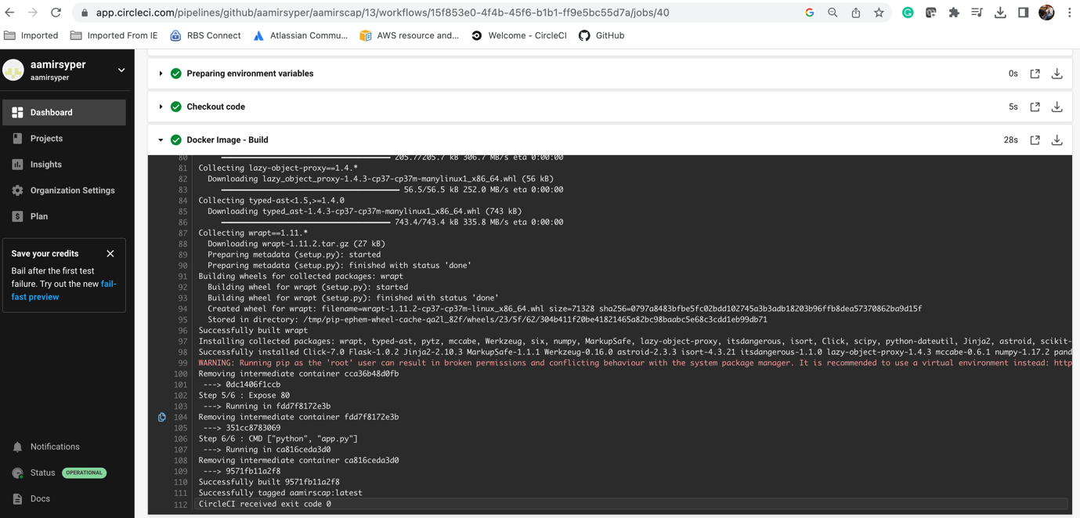

**Docker Image List**

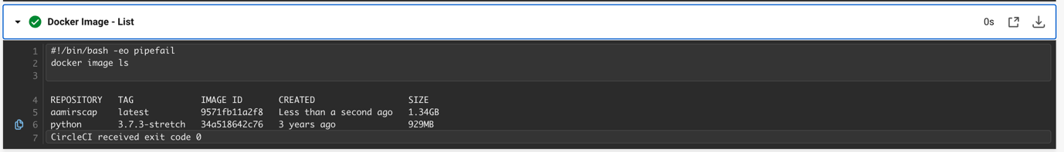

**Docker Image Push**

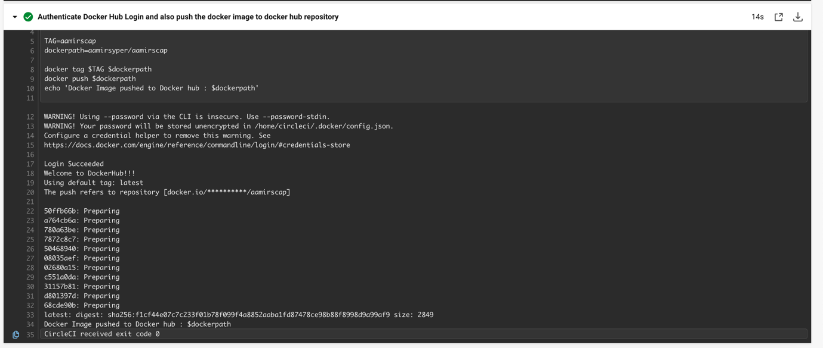

**Docker Hub**

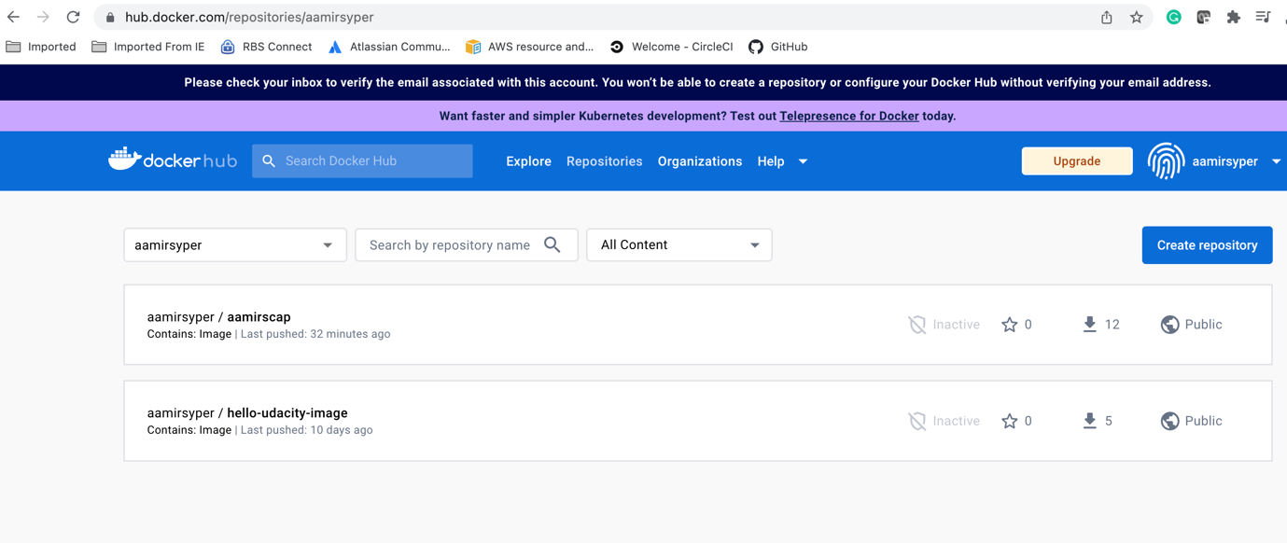

**Cluster Creation**

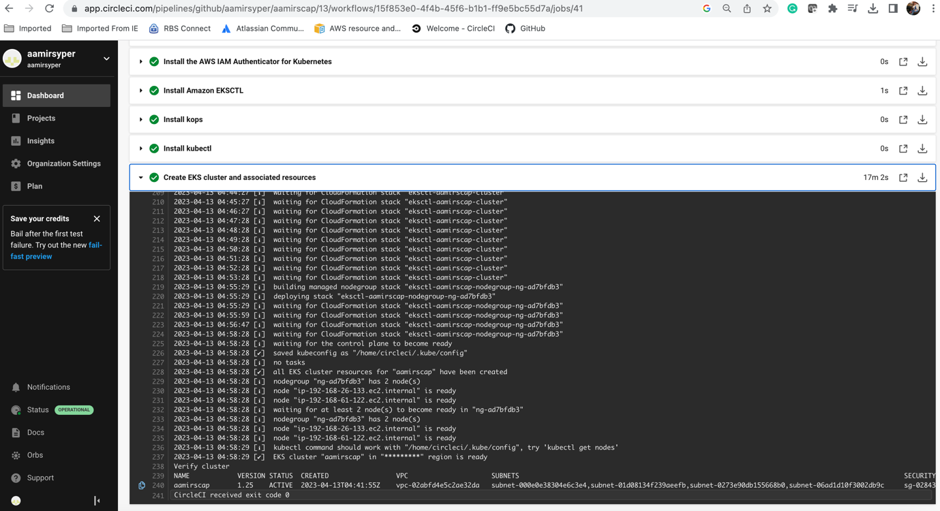

**Successful Deployment**

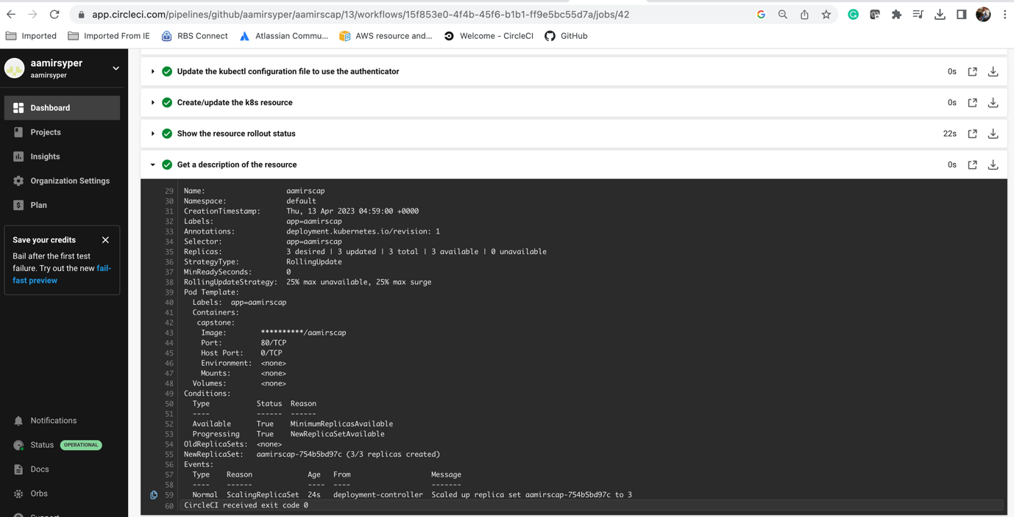

**Resource Rollback**

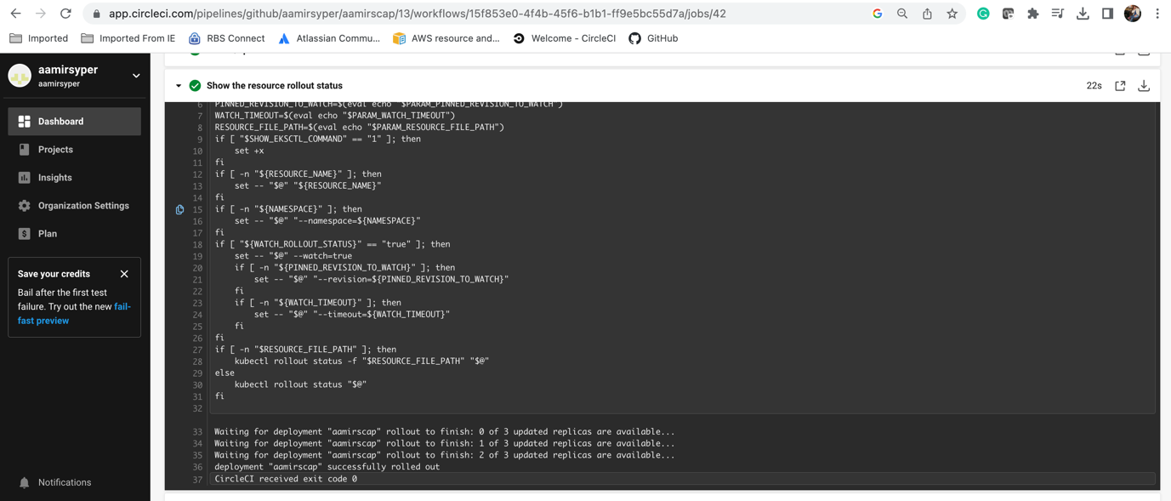

**Webapp**

